PROJECT REPORT

**PROJECTTITLE:** STREAMLING TICKET ASSIGNMENT FOR EFFICIENT SUPPORT OPERATIONS

**TEAM ID:** NM2025TMID19219

**TEAM LEADER:** PRIYANGA M

**TEAM MEMBER**:MUTHU ERULAYEE N

**TEAM MEMBER:** THIRISHA J

**TEAM MEMBER:** SURITHIKA B

**Streamling ticket assignment for efficient support operations**

**Problem Statement:**

In customer support operations, income tickets are often frequently routed manually or through simple rule-based mechanisms. This creates several challenges: slower response time, imbalanced workload distribution across support representatives and limited ability to prioritize critical issues. As ticket volumes increase, manual routing becomes more error-prone and time-consuming, resulting in reduced

Customer satisfaction and operational inefficiency.

**Objective:**

Streamlining ticket assignment is a game-changer for support operations, especially when the goal is to boost efficiency, reduce resolution time, and improve customer satisfaction. Here’s a breakdown of key objectives and strategies to achieve them:

**Objectives for Efficient Ticket Assignment:**

* **Minimize Resolution Time** : Automatically route tickets to the right team or agent based on issue type, priority, or customer profile.
* **Balance Workloads :** Use load-based or round-robin distribution to ensure no team member is overwhelmed.
* **Enhance Accuracy :** Reduce human error by automating categorization and assignment using predefined rules or AI-driven logic.
* **Improve Visibility & Reporting :** Implement dashboards to track ticket flow, team performance, and bottlenecks.
* **Boost Customer Satisfaction :** Faster, more accurate responses lead to happier customers and better retention.

**Skills:**

Users, Groups, Roles, Table, Assign roles & users to groups, Assign role to table, create ACL, Flow.

**TASK INITIATION**

# Milestone 1: Users

**Activity 1: Create Users**

1. Open service now
2. Click on All >> search for Users
3. Select user under system security
4. Click on new
5. 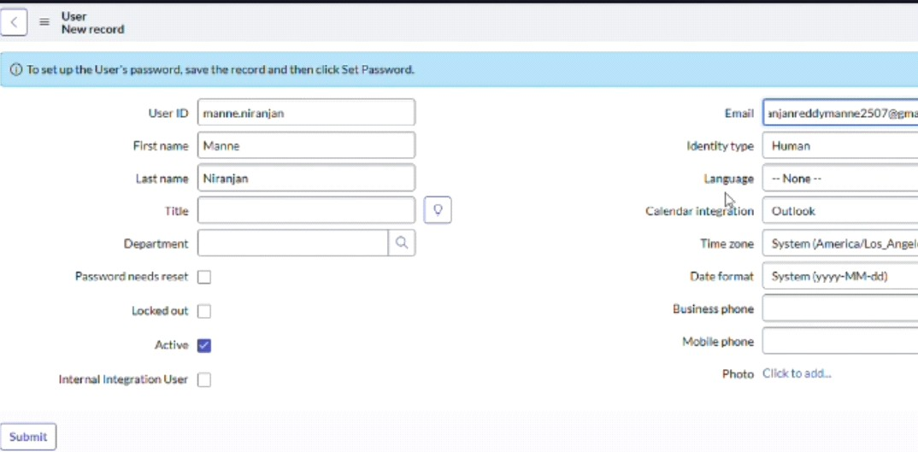Fill the following details to create a new user

6.Click on Submit

Click one more

user

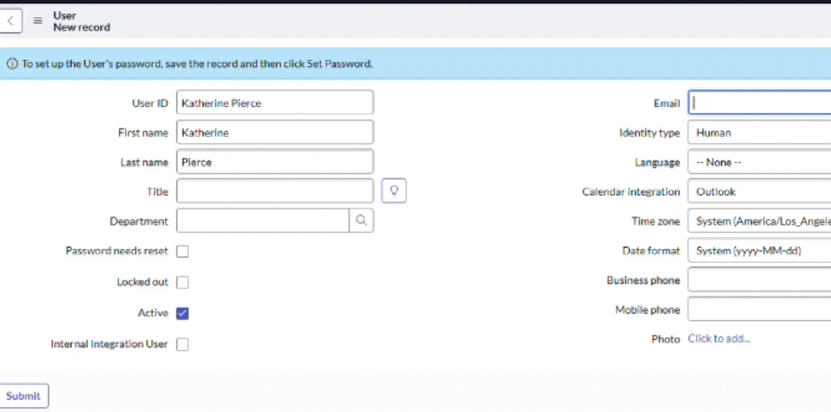

**Activity 1: Create Groups**

* 1. Open service now
  2. Click on All >> search for groups
  3. Select user under system security
  4. Click on new
  5. Fill the following details to create a new group

6. Click on submit

7. Create one more groups

1. Create another group with the following details

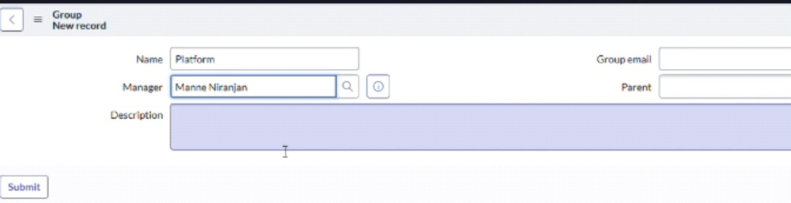

1. Click on submit

# Milestone 3: Roles

**Activity 1: Create Roles**

* + 1. Open service now
    2. Click on All >> search for roles
    3. Select user under system security
    4. Click on new
    5. Fill the following details to create a new role

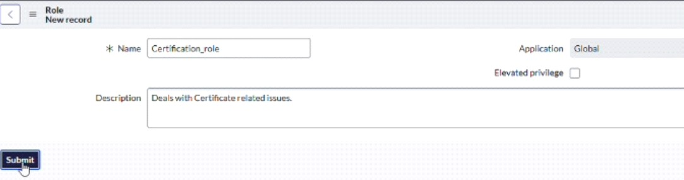

6.click on submit

Create one more

role

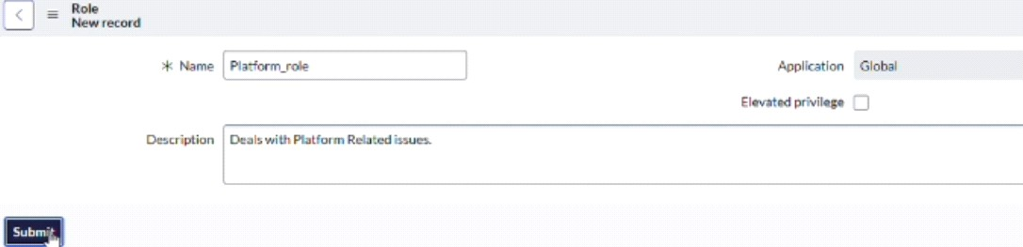

8.Click on submit.

# Milestone 4: Table

**Activity 1: Create Table**

* + - 1. Open service now
      2. Click on All >> search for table
      3. Select user under system security
      4. Click on new
      5. Fill the following details to create a new table Label: Operation related

Checked the boxes create modules & create mobile module

* + - 1. Under new menu name: Operations related
      2. 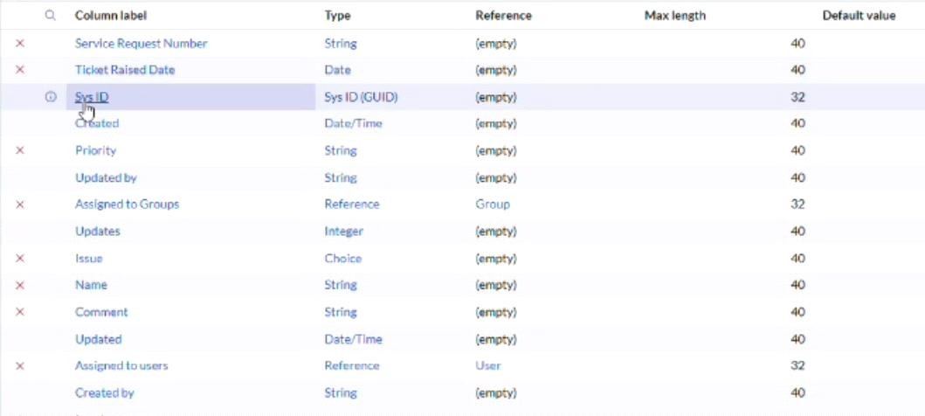Under table columns give the columns
      3. Click on submit

Create choices for issue filed by using form design Choices are

* + - * 1. Unable to login to platform
        2. 404 error
        3. Regarding certificate
        4. Regarding user expired

# Milestone 5: Assign Roles & Users to Group

**Activity 1: Assign Roles & User to Certificate Group**

1. Open service now
2. Click on All >> search for tables
3. Select user tables under system definition
4. Select the certificate group
5. Under group members
6. Click on edit
7. Select Katherine pierce and save
8. Click on roles
9. Select certification_ role and save

# Activity 2: Assign Roles & User to Platform Group

1. Open service now
2. Click on All >> search for tables
3. Select user tables under system definition
4. Select the platform group
5. Under group members
6. Click on edit
7. Select Manne Niranjan and save
8. Click on roles
9. Select platform_ role and save

# Milestone 6: Assign Roles to Table

1. Open service now
2. Click on All >> search for tables
3. Select operations related table
4. Click on the application access
5. Click on u_ operations_ related read operation
6. Click on the profile on top right side
7. Click on elevate role
8. Click on security admin and click on update
9. Under requires role
10. Double click on insert a new row
11. Give platform role
12. And add certificate role
13. Click on update

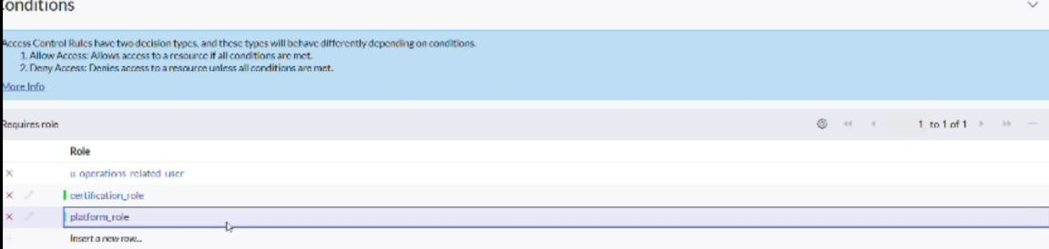

# Milestone 7: Create ACL

1. Open service now
2. Click on All >> search for tables
3. Select Access Control (ACL) under system security
4. Click on new
5. 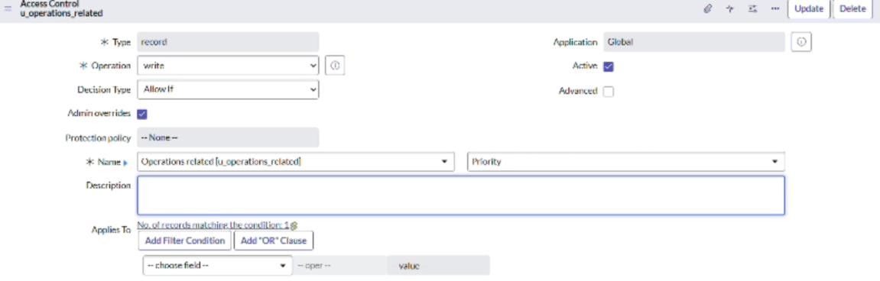Fill the following details to create a new ACL
6. Scroll down under requires role
7. Double click on insert a new row
8. Give admin role
9. Click on submit
10. Similiarly create 4acl for the following fields



# Milestone 7: Flow

**Activity 1: Create a flow to assign operation ticket to group**

1. Open service now
2. Click on All >> search for tables
3. Click on flow designer under process automation
4. After opening flow designer click on new and select flow
5. Under flow properties Give Flow Name as “Regarding Certificate”
6. Application should be global
7. Select Run user as “System user” from that choice
8. Click on submit.

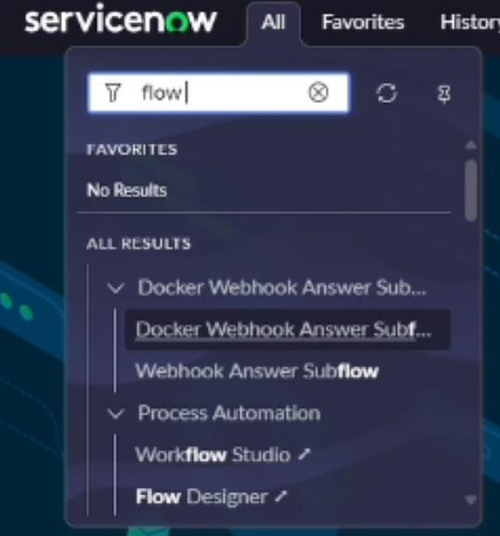

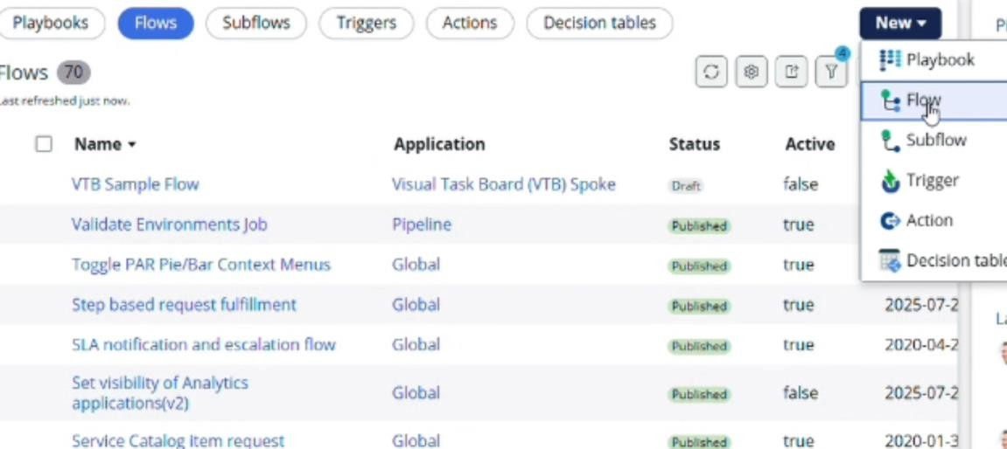

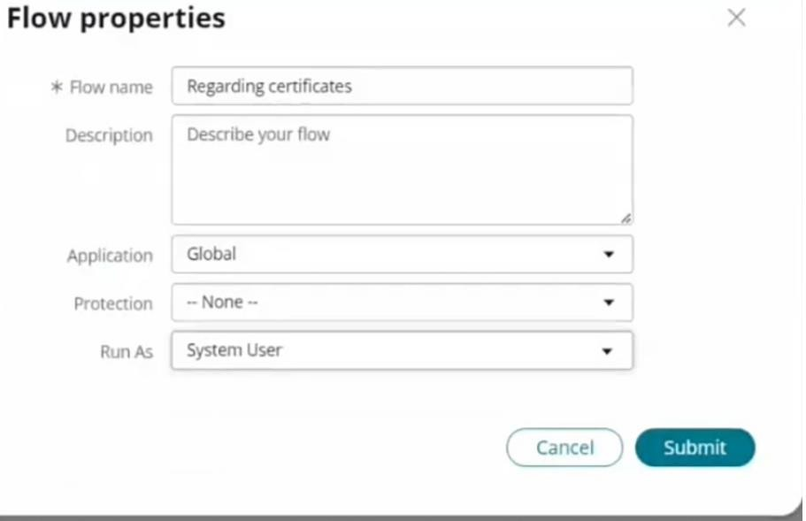

1. Click on add a trigger
2. Select the trigger in that search for "create or update a record" and select that.
3. Give the table name as "Operation related"
4. Give the condition as field: issue operation is

Value: Regrading Certificate

1. After that click on Done
2. Now under action
3. Click on add an action
4. Select action in that search for "Update Record"
5. In Record field drag the fields from the data navigation from left side
6. Table will be auto assigned after that
7. Give the field as "Assigned to group"
8. Give value as "Certificates"
9. Click on Done.
10. Click on save to save the Flow.
11. Click on Activate.

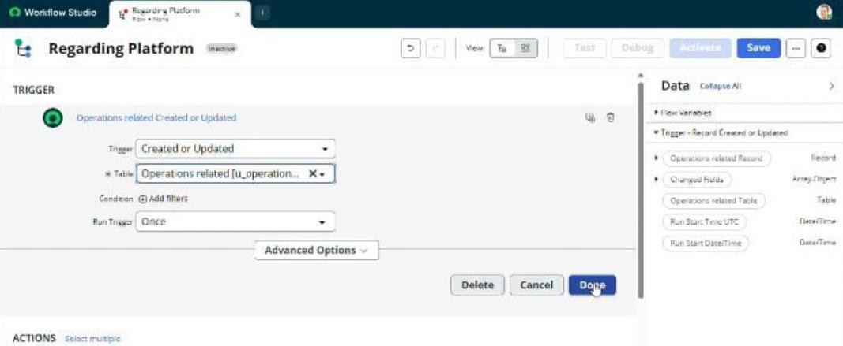

# Activity 2: Create A Flow To Assign Operations Ticket To Platform Group

1. Open service now
2. Click on All >> search for flow designer
3. Click on flow designer under process automation
4. After opening flow designer click on new and select flow
5. Under flow properties Give flow name as "Regarding platform"
6. Application should be Global
7. Select Run user as "System user "from that choice
8. Click on submit
9. Click on Add a trigger
10. Select the trigger in that search for "create or update a record" and select that
11. Give the table name as "Operation related"
12. Give the condition as:

Field: issue

Operation: is

Value: Unable to login to platform

1. Click on new criteria

Field: issue

Operation: is

Value: 404 Error

1. Click on new criteria

Field: issue

Operation: is

Value: Regrading user expired

1. After that click on done
2. Now under actions
3. Click on add an action
4. Select action in that search for "Update Record"
5. In record field drag that fields from the data navigation from left side
6. Table will be auto assigned after that
7. Give the field as "Assigned to group"
8. Give value as "Platform"
9. Click on Done
10. Click on save to save the flow
11. Click on activate

# Conclusion:

Streamlining ticket distribution is a crucial factor in running efficient support operations. Through automating routing, prioritizing based on urgency and expertise, and the use of data-driven insights, organizations can shorten response times, make better use of resources, and improve customer experiences. A well-structured ticket allocation process reduces delays,fosters accountability,and enable support teams to resolve issues more quickly and efficiently. In turn, this drives higher operational productivity, evevates service standards, and strengthens customer trust and loyalty.